Lab Skills

[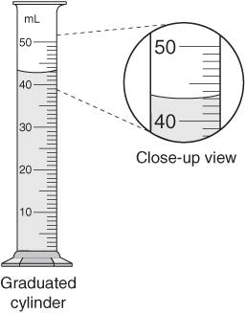](http://www.google.com/url?sa=i&rct=j&q=graduated+cylinder+with+water&source=images&cd=&cad=rja&docid=6EAnb_Jg5c7ZgM&tbnid=CiBjOewsvg86OM:&ved=0CAUQjRw&url=http://chemwiki.ucdavis.edu/Analytical_Chemistry/Quantifying_Nature/Significant_Digits/Uncertainties_in_Measurements&ei=HT4nUojwFIWWqQHAwIGoAw&bvm=bv.51495398,d.aWM&psig=AFQjCNGRKoxsJ9KljeFsyIBJNw1Dn-opAA&ust=1378389893927795)In the lab, you will be using many skills in order to accomplish the objective of each lab. Some skills you will use more frequently than others. In this activity, you will learn and practice measuring (both liquid and solid volume), lighting and adjusting a Bunsen burner.

When measuring the volume of a liquid you must **ALWAYS USE A GRADUATED CYLINDER** and read from the bottom of the meniscus (the bottom of the curve). You must also be able to read to correct decimal place. The rule is always read to what you KNOW and then estimate the last decimal place. The process should look like this:

1. Liquid is definitely between 40 & 50mL
2. Liquid is definitely between 43 & 44mL
3. Estimated volume is 43.1mL

*this graduated cylinder will always read to the “tenths” place*

**Measuring**:

**Liquids**:

Fill 2 different graduated cylinders about half way and record the volume (don’t forget units!):

Volume 1:________ Volume 2:___________

Does the accuracy (the decimal place) change from cylinder to cylinder? (If so, how?)

**Solids:** As you have learned before an objects volume is defined as its length, width and height all multiplied together. However some shapes are irregular, which makes it difficult to measure the dimensions with a ruler. Instead of attempting to measure the dimensions of the object, we will use a technique called **water displacement**. Here are the steps for water displacement: fill a graduated cylinder roughly half way with water and record the initial volume. Then add the *dry* object to the cylinder by tilting the cylinder and sliding the object down the side, making sure that the liquid then covers the entire object. Record the final volume and subtract the two volumes. The water that was displaced (final volume – initial volume) by the object will be the volume of the object.  
Predict/estimate the volume of the two objects:

Volume 1:_______ Volume 2:_________

Determine the volume of two irregularly shaped objects using water displacement:

Volume 1(initial):_______ Volume 1(final):_______ Volume 1:_______ Volume 2(initial):_________ Volume 2(final):_________ Volume 2:_________

**Bunsen burner:**

When using the Bunsen burners you must always use caution. These are one of the most common pieces of equipment we will use and they will be one of the most dangerous as well. You will need to know how to do the following:

1. **Lighting a Bunsen burner**:

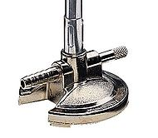Make sure the gas nozzle is turned OFF. Ready the striker in one hand. Turn on the gas slowly with the other, press the flint against the steel and quickly and firmly move the flint across the steel to create a spark until the burner lights. **Turn off your gas if you are having issues***

1. 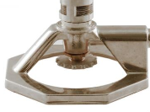**Adjust the height of the burner (2 possible ways):**

Adjust the gas nozzle against the wall either open or closed.

If your Bunsen burner has a wheel on the bottom or a nozzle

on the side, those will adjust gas flow as well

1. **Adjust the temperature of the flame:**

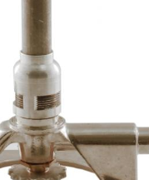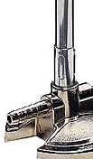You will notice that the Bunsen burner flame will be able to be present in two main colors: Red and Blue. The **red** flame is what we call the **cool** flame. The **blue** flame is considered the **hot** flame. In order to change the temperature (and color) you must change the oxygen intake. The air intake valves will be located just above the gas intake stream (where the rubber rube connects).

What makes a hotter flame, more air (oxygen) or less air (oxygen)?

**Determine the hottest part of the flame:**

As you now know the blue flame is the hotter of the two types of flames you can produce with the bunsen burner. That flame has a “hot spot”. The hottest part of the blue flame will be the **inner blue cone.** This is important to know when you are adjusting the height of heating anything in the lab. You should be able to create this if you create the correct oxygen to gas ratio in your burner.  
  
Create a blue flame and point out to your lab partner the inner blue flame. Draw what you see below.